Installing python in windows :

1. Download the latest version of python for windows from python.org

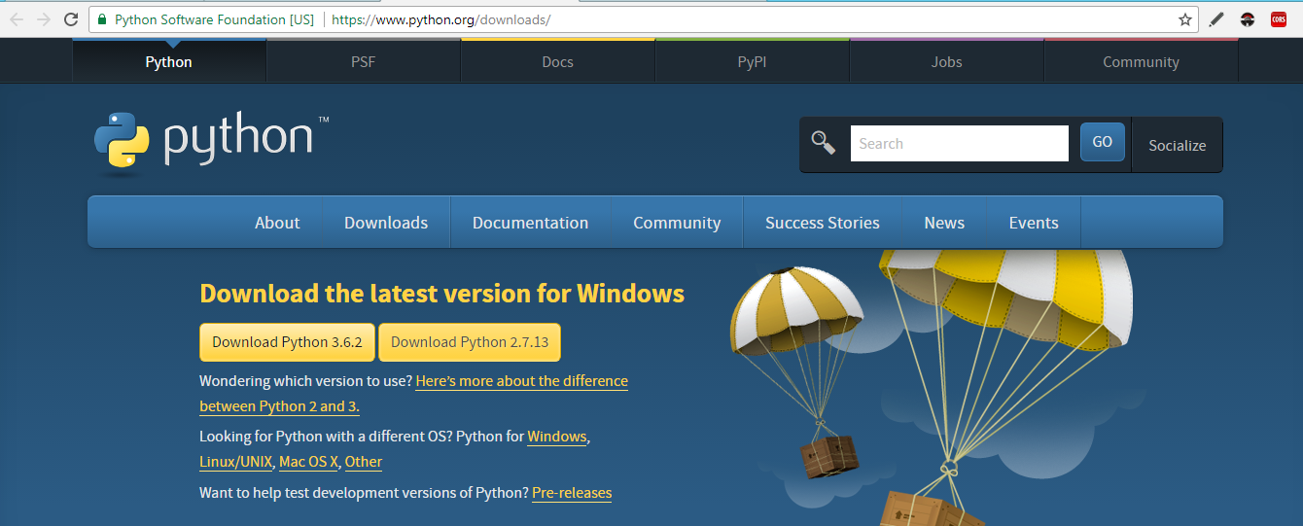

1. Run python installer :

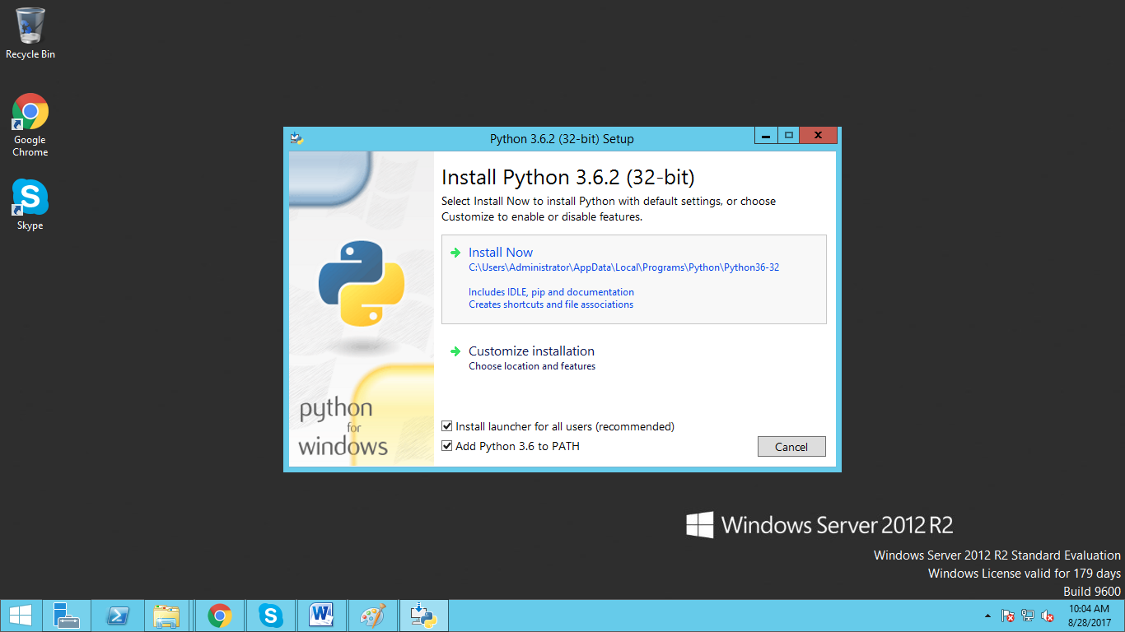

1. After installing python, run cmd, type “python”. If you see the correct version number, then python is successfully installed in your system.

